**Kickstarter Campaign Analysis Report**

1. **Summary of Project Status by Category**

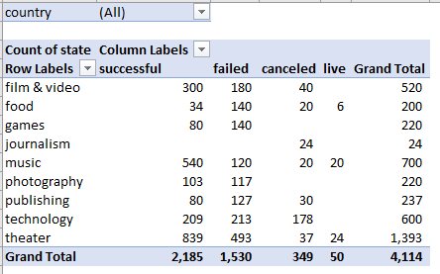

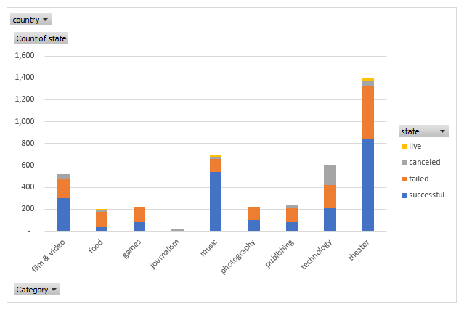

1. **Summary of Project Status by Subcategory**

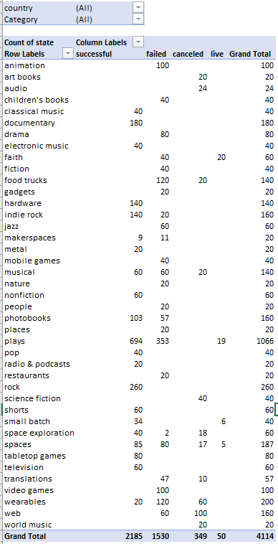

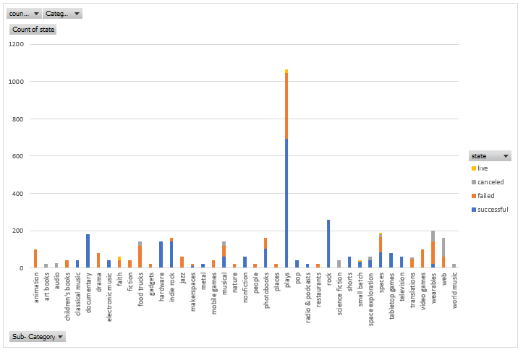

1. **Summary of Project Status by Month**

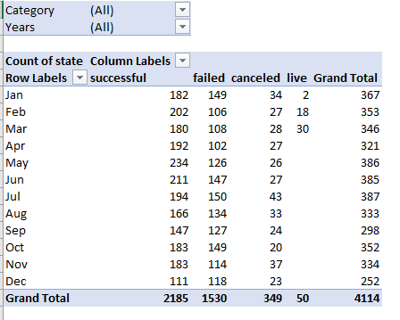

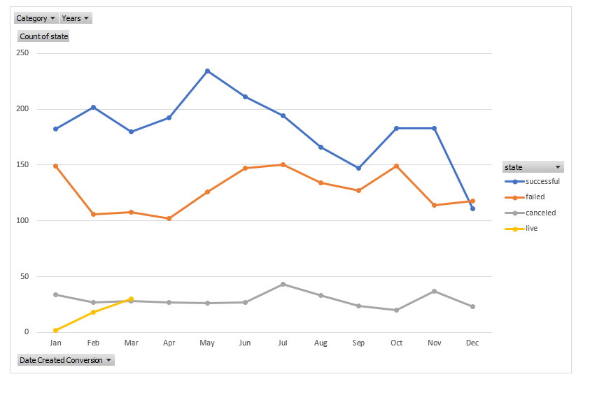

1.The three conclusions that can be drawn about the Kickstarter campaigns are:

* The theater campaigns had the most successful outcomes. The theater campaigns have 3 categories; musical, plays and spaces. Plays is the leading category in successful campaigns.
* Approximately 53% of all campaigns initiated are successful
* Whilst plays have the largest number of successful campaigns, they also have the largest number of failed campaigns.

2. Limitations of the dataset

* Information about the participants e.g., age, social standing, interests in category
* Outreach methods- how did the campaigners reach out to the donors
* Methods of fundraising e.g., gala, patrons, email blasts, phone call etc.
* The fundraising organization’s experience in fundraising i.e., is it a new organization or has it been fundraising for a number of years

3. Other possible tables and/or graphs that can be created are

* Campaigns by country
* Amounts raised by category
* Number of backers in relation to status
* Fundraising duration in relation to outcome